5.2: Volume by Slicing and The Disk Method

Solid of Revolution

When a plane region is revolved around a line, called the axis of revolution, the resulting solid is called a solid of revolution.

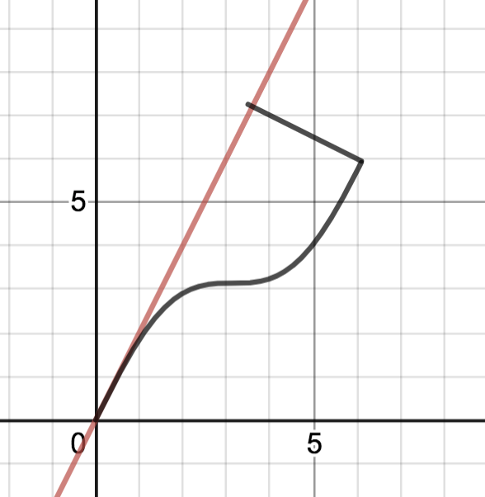 

We will be computing volume for solids of revolutions whose axes are horizontal or vertical. See “Example Solids of Revolutions” on the 5A page. <http://www.cecm.sfu.ca/~nbruin/math152/SOR/solids-of-rev.html>

Disk Method, revolve about X AXIS

Consider a , continuous on [a,b], revolve about the x axis.

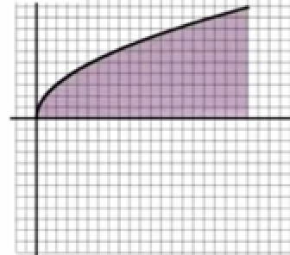 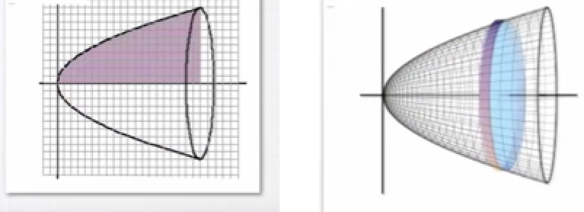

See disk method video on 5A page (first 40 seconds). Consider revolution of typical rectangle.

Example: The region bound by , x=4 and x axis is revolved about the x axis. Find the volume:



Disk Method, revolve about Y AXIS.

Consider , continuous on [c,d], revolve about the y axis.

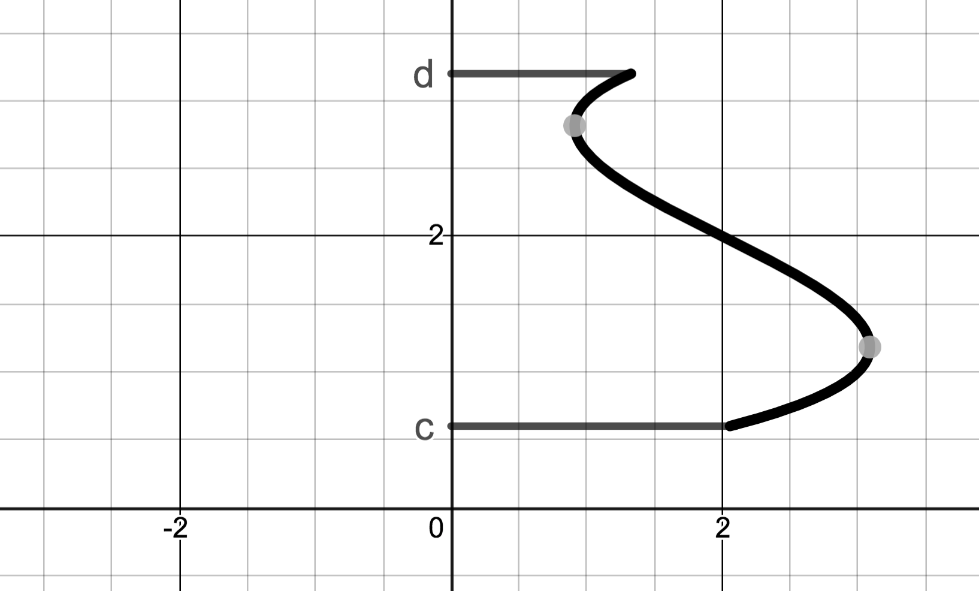 

Example: The region bound by , y=2 and y axis is revolved about the y axis. Find the volume:

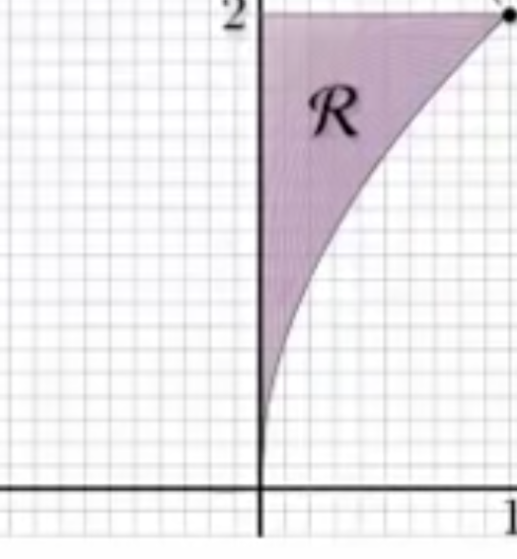 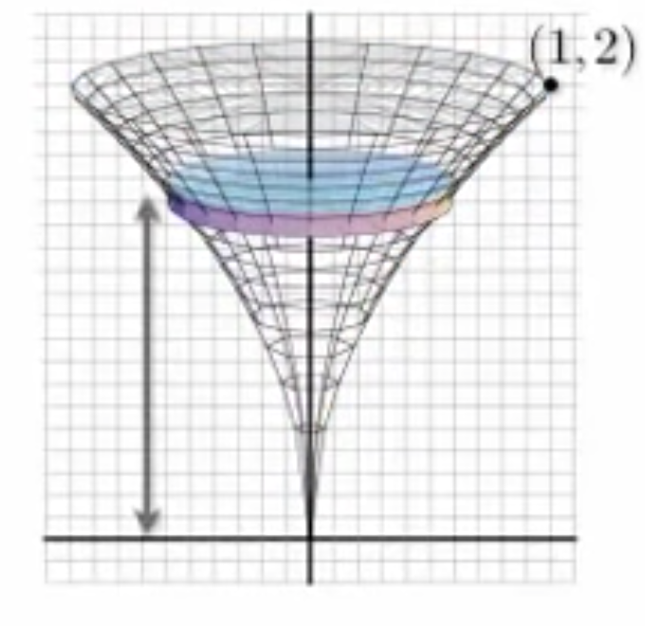

Steps of Disk Method – Rather than *memorize* that disk method about x axis is dx and about the y axis is dy, it is going to help to think and really *understand* what you are doing. You would need to take slices of the solid perpendicular to the axis to of revolution get circular disks. This tells us what variable we will be integrating with respect to. Put the dx or dy in the integral formula first. In the 2D region, draw a representative rectangle perpendicular to the axis of revolution.  where thickness corresponds to dx or dy.

Washer Method

This is a version of the disk method that needs to be applied when the circular disk slices have a hole as shown in the animation [Solid of revolution animation (washer)](https://www.youtube.com/watch?v=3oAjcLD34kc) on the 5A page.

.

Derivation:

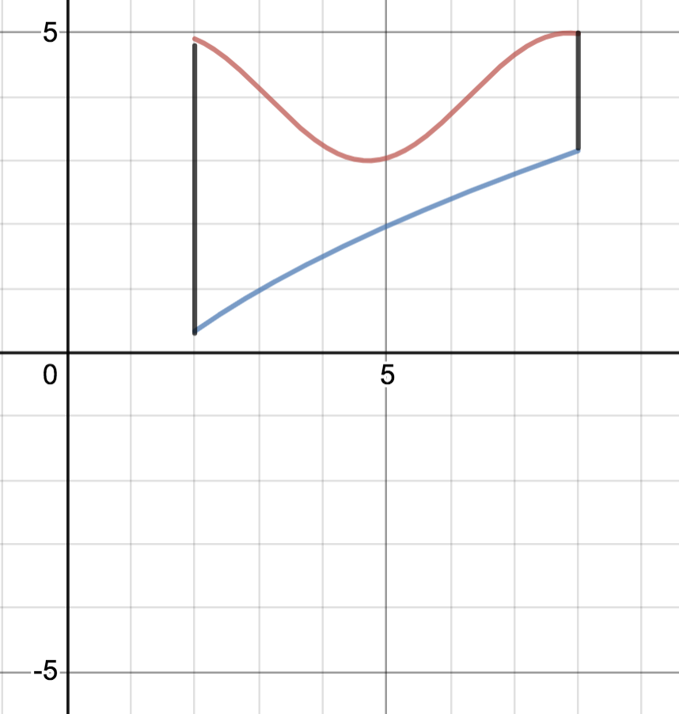

Example: (MathIsPower4U)

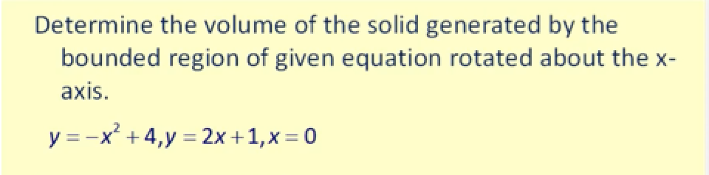

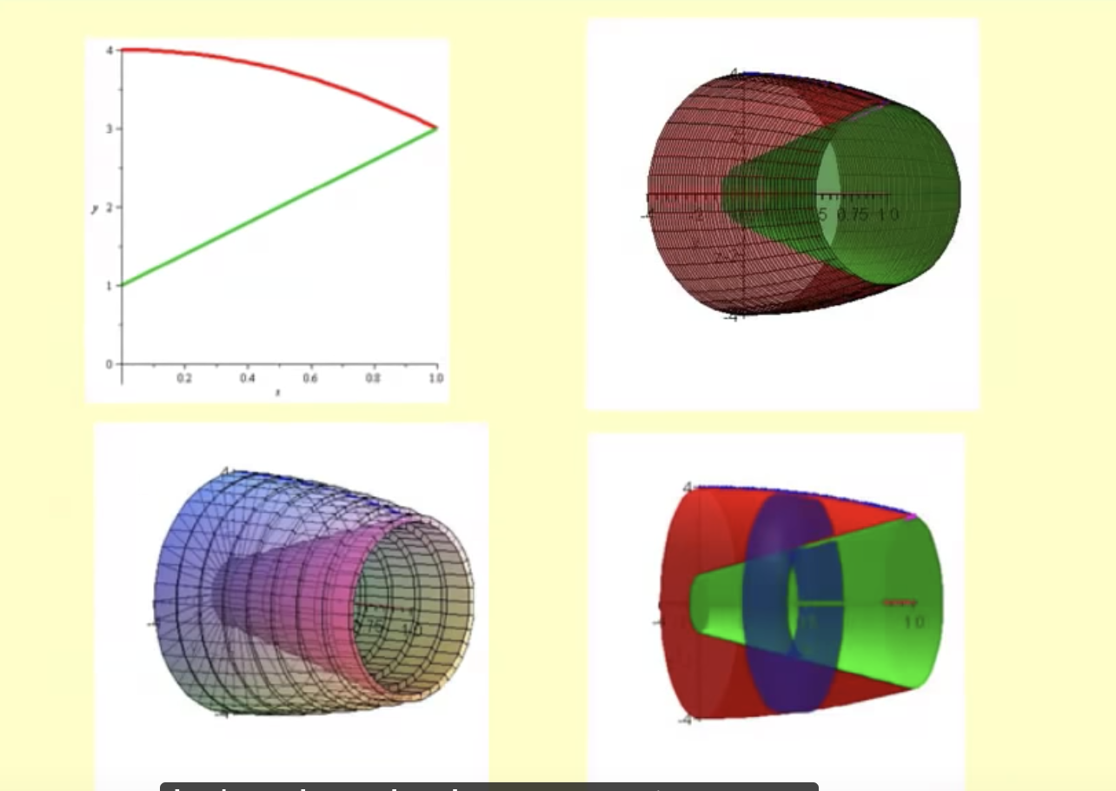

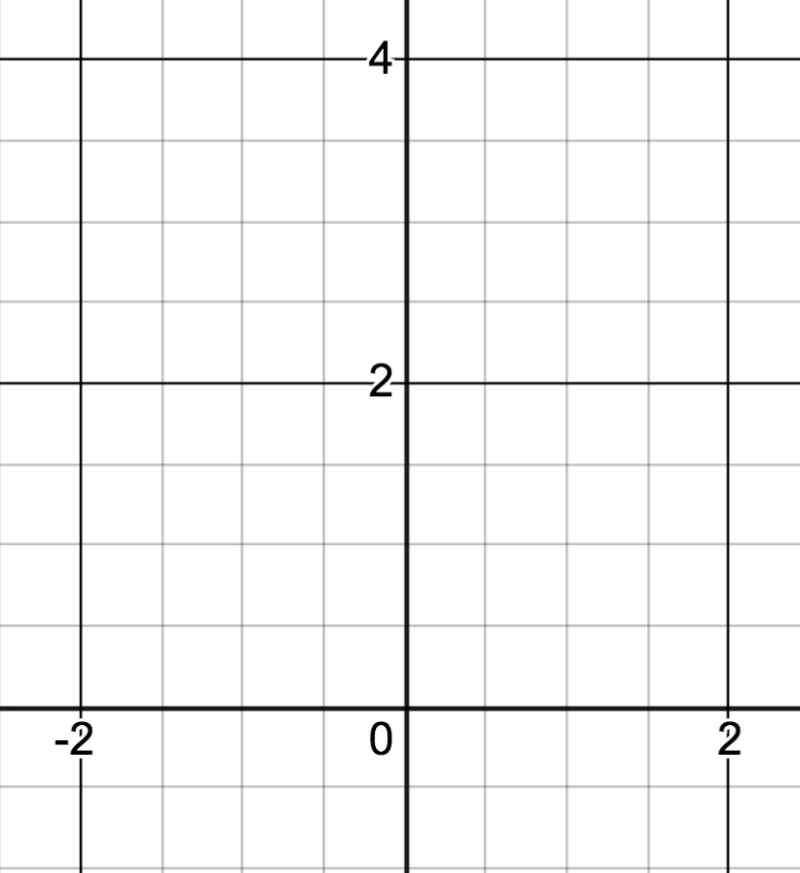Example: Washers about the y axis

Find the volume of the solid generated when the region bound by y=4-x2 and y=0 for x1 is

revolved about the y axis.

Steps of Washer Method – You would need to take slices of the solid perpendicular to the axis to of revolution get circular washers. This tells us what variable we will be integrating with respect to. Put the dx or dy in the integral formula first. In the 2D region, draw a representative rectangle perpendicular to the axis of revolution.  where thickness corresponds to dx or dy.

Example: Revolving about a line other than the x or y axis - Disks.

Find the volume of the solid generated when the region bound by  and the y axis is revolved about the line y=1

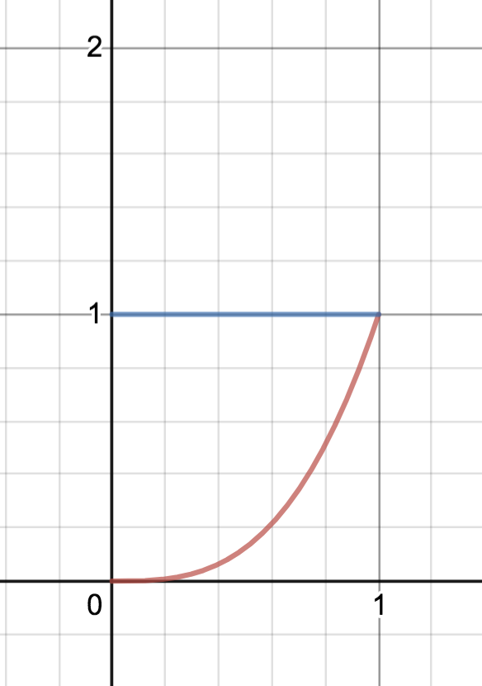

Example: Revolution about line other than axis - washers.

Find the volume of the solid generated when the region bound by  is revolved about the line x=-1

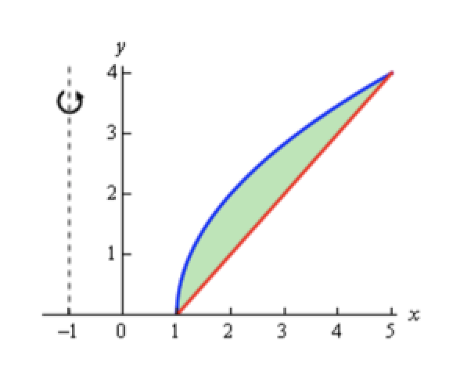 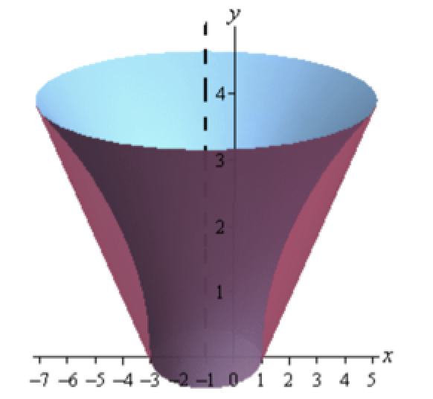

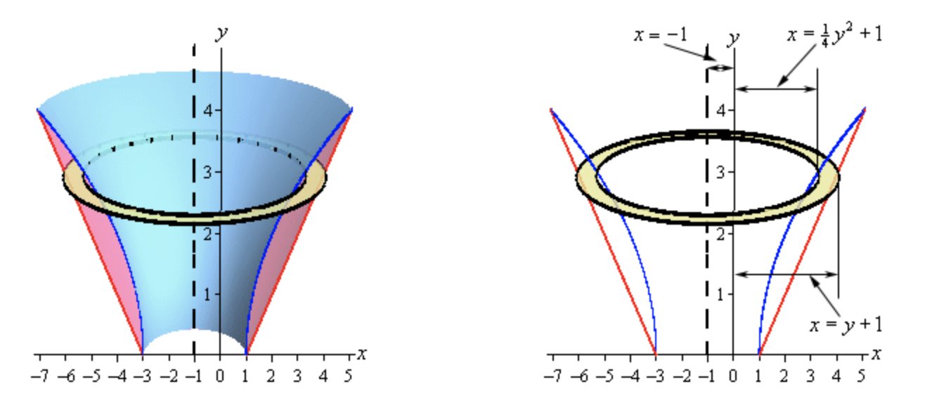

-

5.2 ii Volume by Slicing – Cross sections uniform shape.

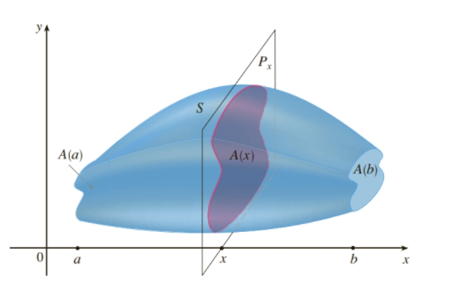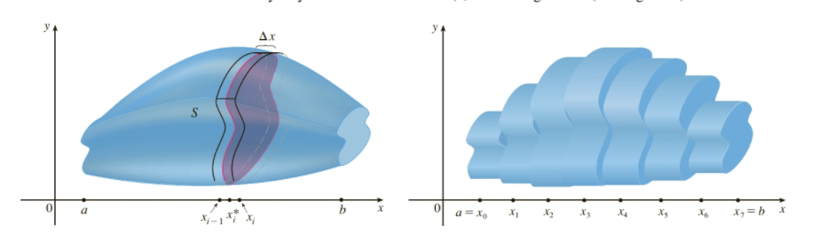

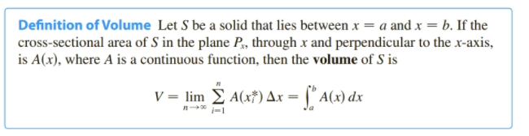

Example: Find the volume of the solid whose base is the region enclosed by  and having square cross sections perpendicular to the x axis.

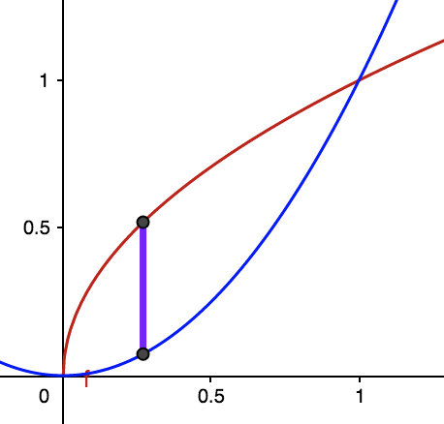 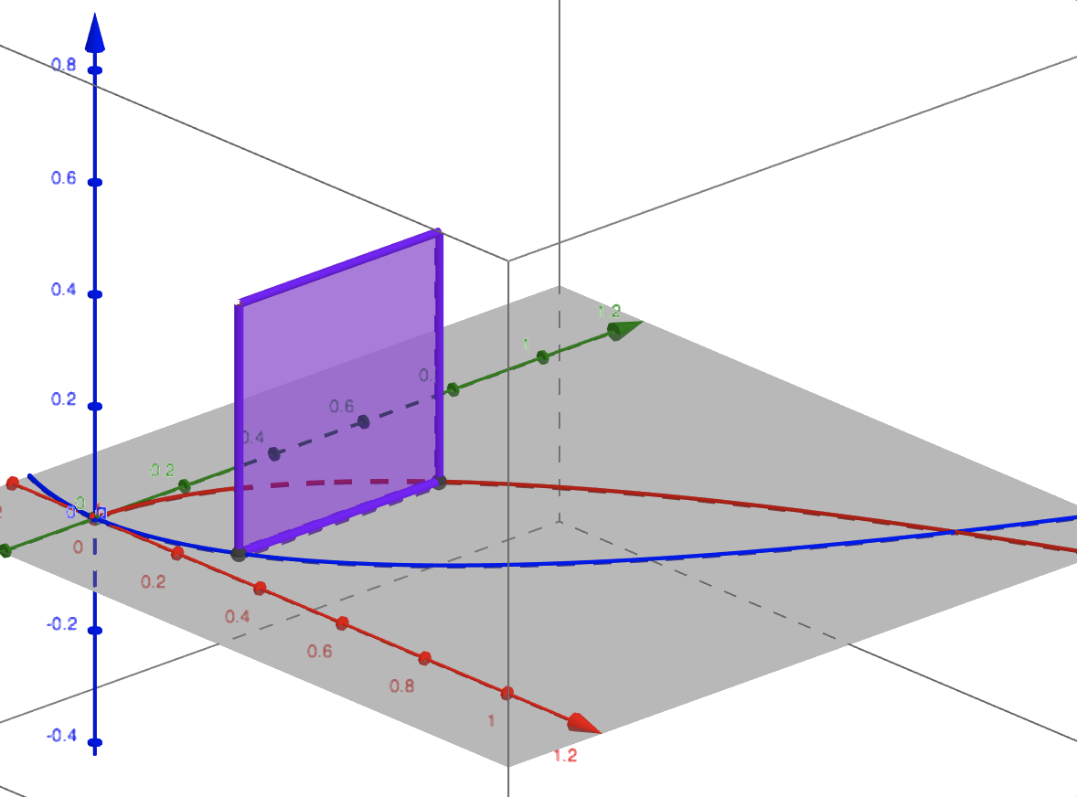

5A page geogebra: <https://www.geogebra.org/m/XFgMaKTy> Many other good examples and visualizations also.

5.3 Method of Cylindrical Shells

Find the volume of the solid formed by revolving the region bound by  and the x axis about the y axis.

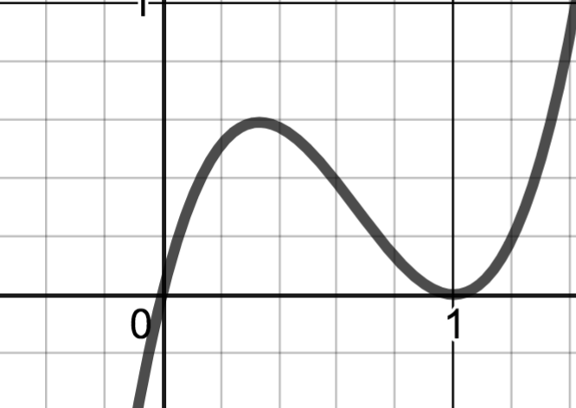 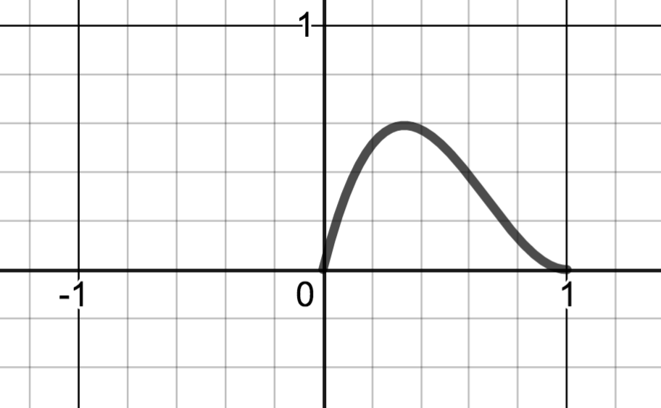

Is there another way?



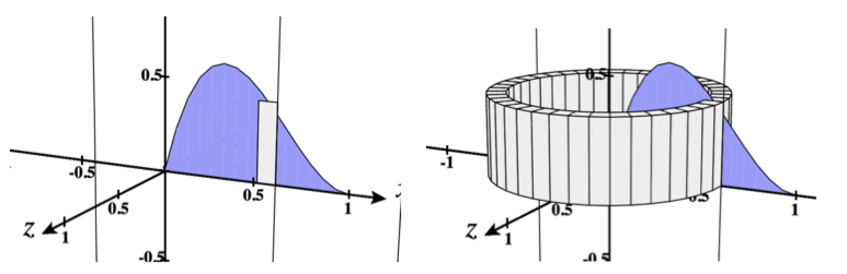

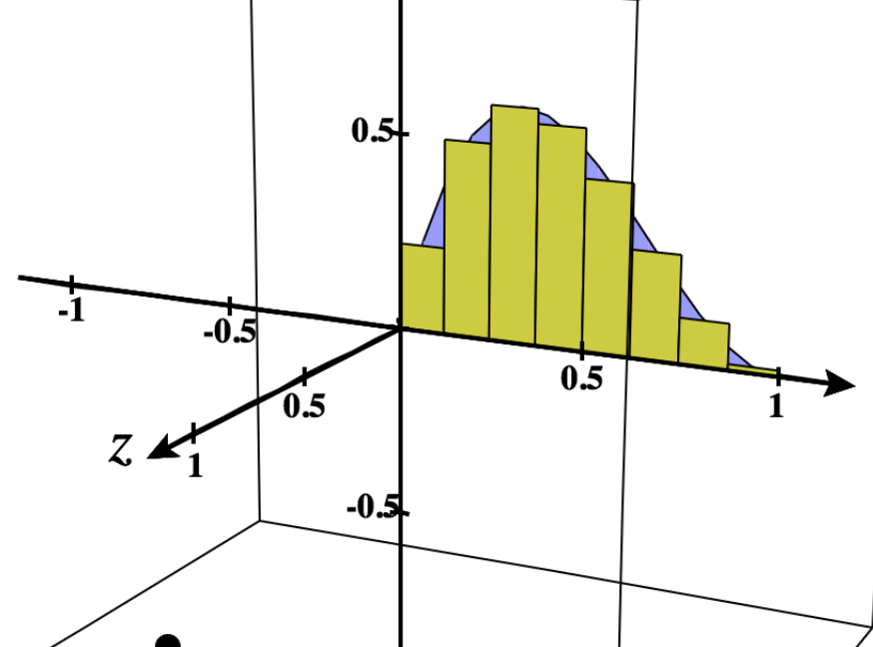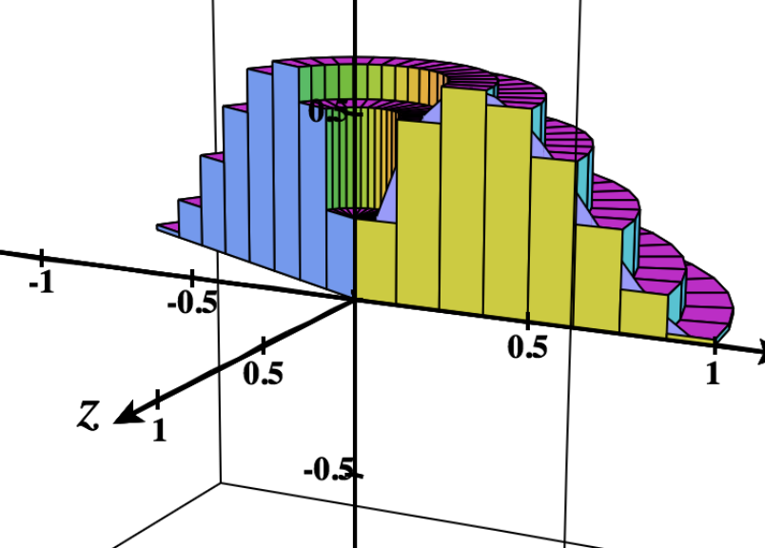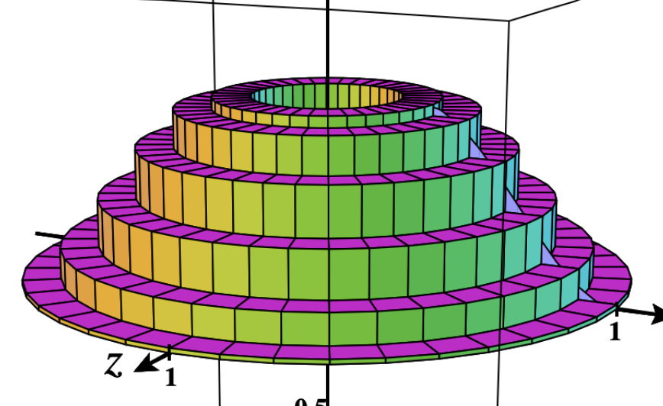

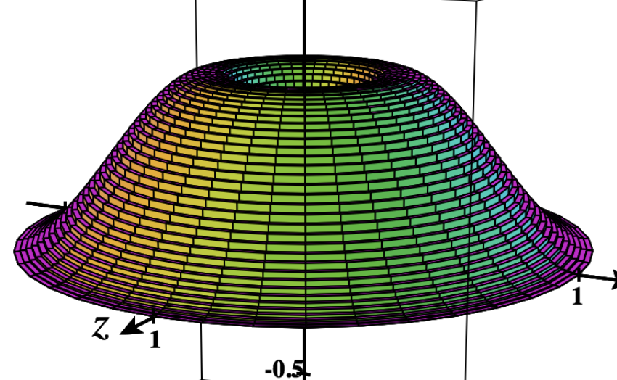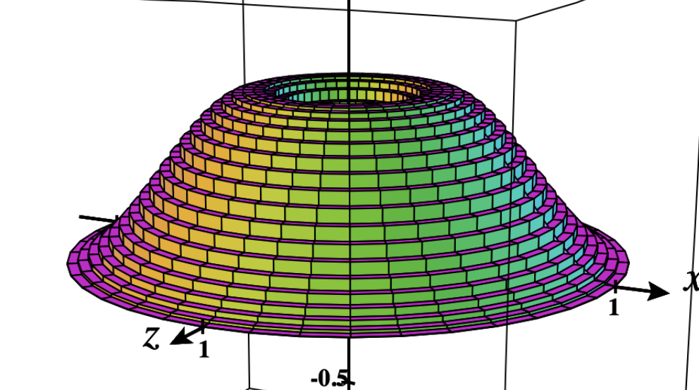

Derivation of the Method of Cylindrical Shells

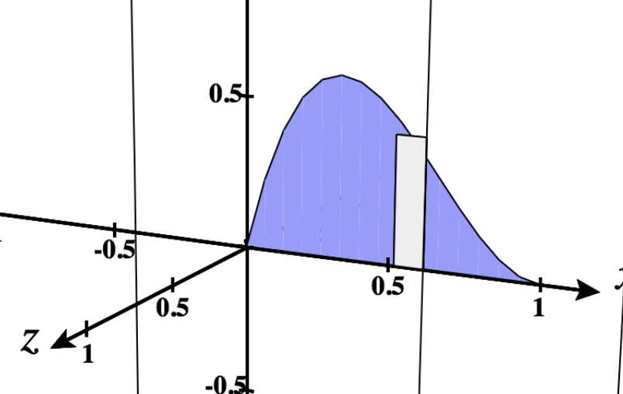 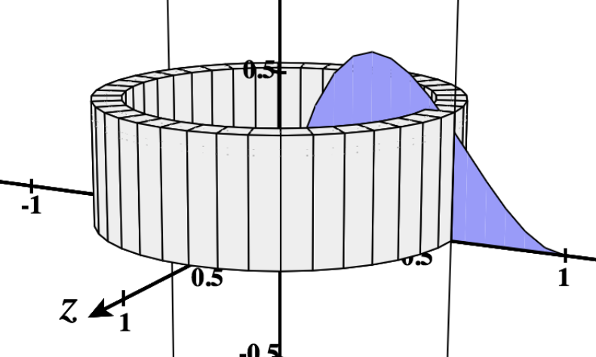

Volume of the ith shell : Can be derived many ways. In section 2.9, we used differentials:

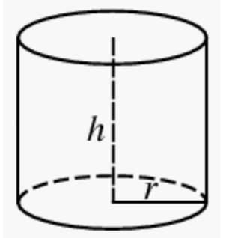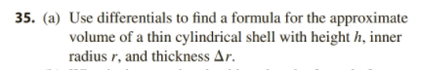 

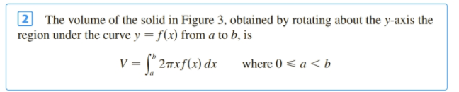 More generally: 

Back to example:  about y axis



Example: Find the volume of the solid formed by revolving the region bound by y=x and y=x2 about the y axis.

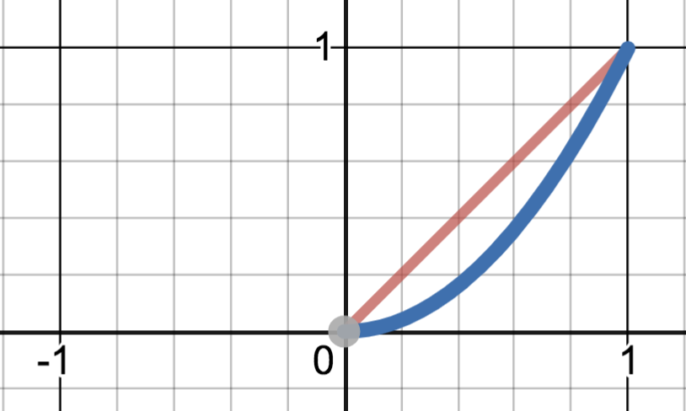 

Shell Method Tips: Draw representative rectangle parallel to the axis of revolution.

Example: Revolve about the x axis . (Done previously using disks)

The region bound by , x=4 and x axis is revolved about the x axis. Find the volume:



Example: Revolution about line other than axis. (Done previously with washers)

Find the volume of the solid generated when the region bound by  is revolved about the line x=-1



Shell Method Tips: Draw representative rectangle parallel to the axis of revolution. The thickness determines dx or dy.

